ONLY FOR DISTRICTS THAT REDUCE # OF DAYS EMPLOYED IN TXEIS DUE TO DISTRICT OF INNOVATION. This document does not apply to Schools that are not a District of Innovation or to schools that are District of Innovation and still use 187 days for contracts.
If you are a District of Innovation and your Teachers, Librarians, Registered Nurses, and Counselors contracts are less than 187 days in TxEIS, then you will need to perform the following steps in order for TxEIS to calculate stat min correctly. TRS requires that districts pay stat min based on 187 days even if their contracts are for less.
Human Resources- Next Year Pay Frequency
1. _____ Go to Human Resources > Maintenance > Staff Job/Pay Data > Job Info
If you do not have 187 days in the # of days employed field for your employees that have a contract for less than 187 days, you will need to proceed with the following steps.

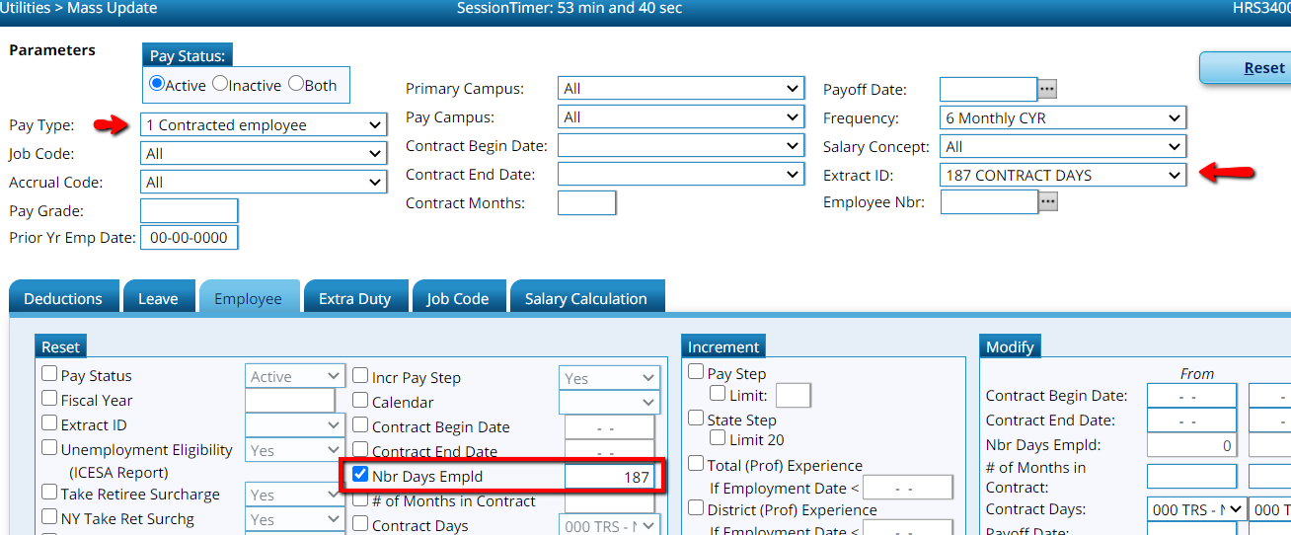
2. _____ Mass Update the Number of Days Employed by going to Utilities > Mass Update > Employee tab. Select the group of employees you want to update by Extract ID (you may also want to select pay type 1 because stat min is not calculated on support staff) > select Nbr Days Employed and type 187 in the box. Execute. Preview the list for accuracy. Select Process to make the change.

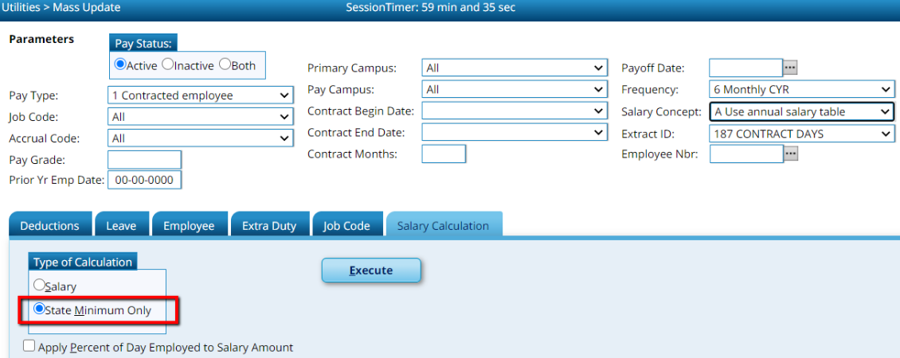
3. _____ Mass Update State Minimum Salary Calculations by going to Utilities > Mass Update > Salary Calculation Tab. Select the same group of employees from prior step. Select the Salary Concept. Select the State Minimum Only radio button. Execute. Preview and select process.

4. _____ Interface NY Payroll to Budget by going to Human Resources > NY Pay Frequency > Next Year Heading > Interface NY Payroll to NY Budget. (See Part 2 document Steps 59-61)

5. _____ Reset the number of days employed back to match contract Utilities > Mass Update > Employee tab > Select the same group of employees from prior steps. Select Nbr Days Employed and type the number of days in employees contract in the box. Execute. Preview the list for accuracy and select Process.
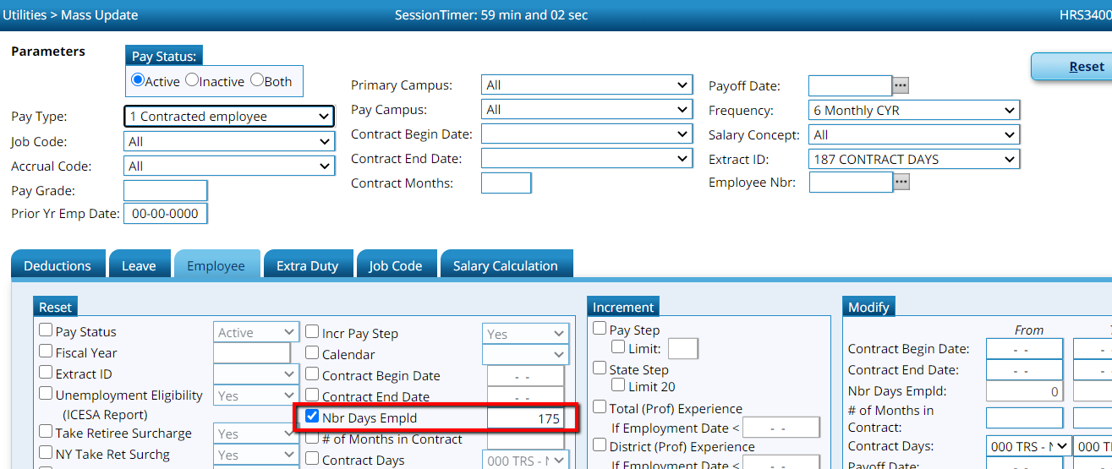

NOTE: BE CAREFUL NOT TO RECALCULATE STAT MIN. WHEN THE WARINING BOX POPS UP ON THE EMPLOYEES SCREEN THAT ASKS IF YOU WANT TO RECALCULATE STAT MIN, YOU WILL WANT TO SELECT NO ON THESE EMPLOYEES. IF YOU SELECT YES, THE SYSTEM WILL AUTOMATICALLY RECALCULATE BASED ON THE NUMBER OF DAYS EMPLOYED WHICH WILL NOT BE ACCURATE FOR TRS REPORTING AND PAYMENTS. 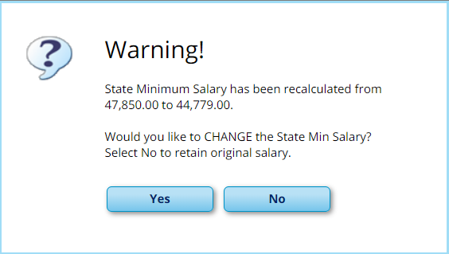

After you pull 10 month employees from next year payroll into current year, you will want to double check your stat min calculations to make sure it is still calculating on 187 days before running September payroll.

